**Comparative cumulative cohort fertility explorer app**

[**https://datascapes.shinyapps.io/cumulative_fertility_app/**](https://datascapes.shinyapps.io/cumulative_fertility_app/)

**01 October 2018**

Inspired by the suggestions and comments provided by the guest editor team, we have developed an online resource (<https://datascapes.shinyapps.io/cumulative_fertility_app/>) as a supporting material for the paper. The online resource offers options to explore different colour palettes with which the level-plot element of the visualization is displayed, the number of related shades, the position, number and colour of contour lines, and so on.

The app also allows any combinations of the 45 countries within the combined HFD and HFC collection to be visualized. This means that users are free to customise the visualizations and apply them to any particular combination of interest to them, and to adjust aesthetic options such as to be most preferable to them. Once the composite level plots have been produced, they can be downloaded in a wide range of image formats, including both bitmap and vector graphics formats, and at a wide range of sizes.

Two CCLP involves plotting two types of linked fertility data on the same Lexis surface range: age-specific fertility rates by cohort using colour/shade; and cumulative cohort fertility levels using contour lines. To further develop the reader’s intuitions for what these two surfaces look like, the tabs ‘3D surface plot’ and ‘linked plots’ both show 3D representations of the ASFRs by cohort and CCFRs as shown in the CCLPs. For example, this is what the ASFR by cohort for Scotland looks like in the CCLP:



And this is what the 3D visualization of the ASFRs for the same population looks like when viewed from above:

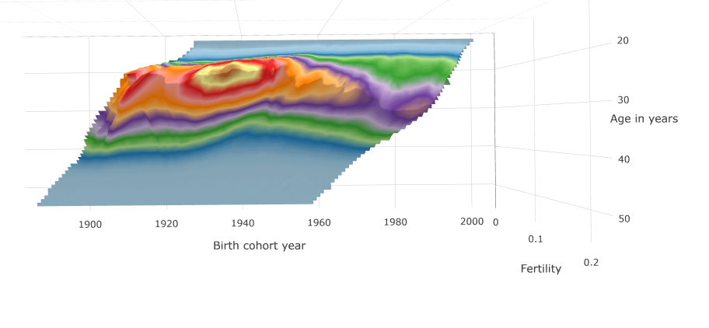

And from the side:

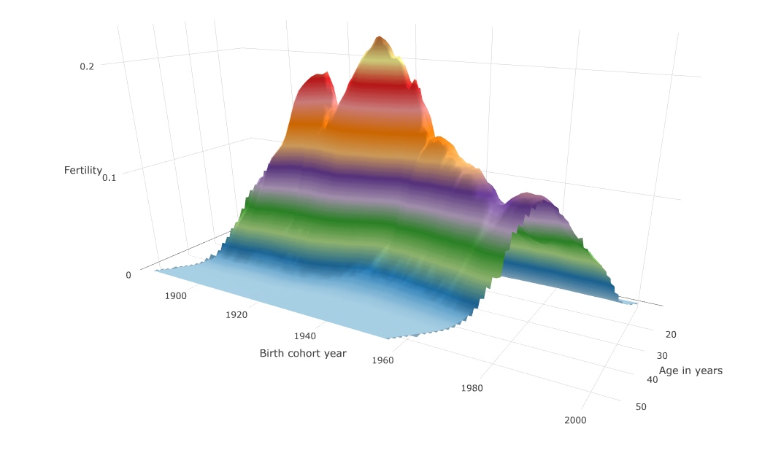

It should be noted that the age axes are reversed between these two plots, due to the different default options used by the two graphics rendering packages used to produce the two types of visualization (Lattice for CCLPs, and Plotly for the 3D plots). But it should still be clear that both are representations of the same attribute relating to the same data.

To facilitate a deep understanding of both the shape of cumulative cohort fertility surfaces, and also of what contour lines represent, the 3D surface tab contains options both to visualize the CCFRs, and add horizontal planes to these surfaces which correspond to the cumulative fertility ‘milestones’ specified through the contour adjustment sliders:

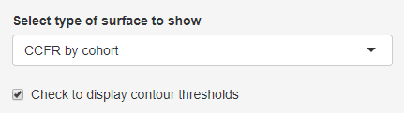

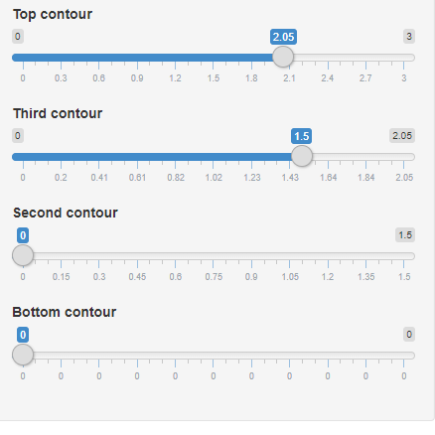

(n.b. these sliders are made visible by selecting the ‘check to adjust contour lines’ option within the composite plot tab, but remain visible when the ‘3d surface plot’ tab is switched to.)

With the contour planes set at 1.5 and 2.05 as above, the CCFR surface for Scotland looks as follows:

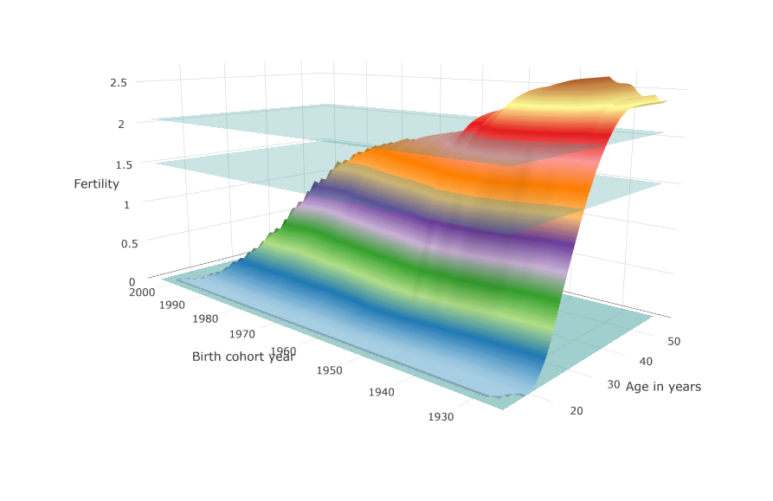

It is clear from these visualizations both that the surfaces are necessarily monotonically increasing with increasing age for any birth cohort, and also that the CCFR surfaces intersect with the planes at different ages and birth years. These intersections between horizontal planes and CCFR surfaces define the positions of the contour lines. This can be seen by looking at the visualization from above:

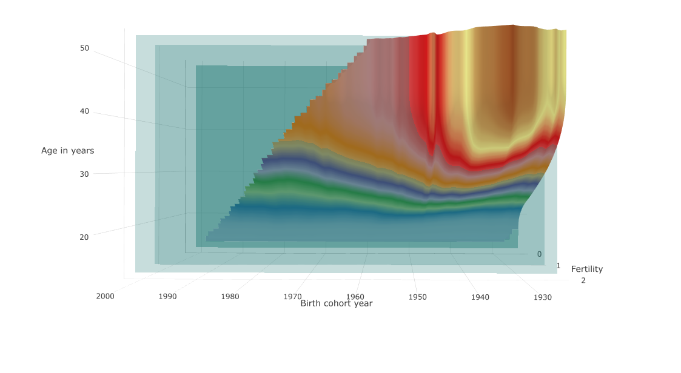

As each of the horizontal planes is translucent and blue-tinged, when the surface passes through a plane the surface behind the plane adopts a blue tinge;

it is therefore relatively straightforward to see where the CCFR surfaces pass through these planes, which is what the contour lines on the CCLP show. This is further supported by disabling the horizontal plane displays and hovering the cursor over part of the surface whose CCFR is at (or near) either of the contour values; in addition to tooltips, other parts of the surface sharing the same x, y or z value are also highlighted, as shown below: 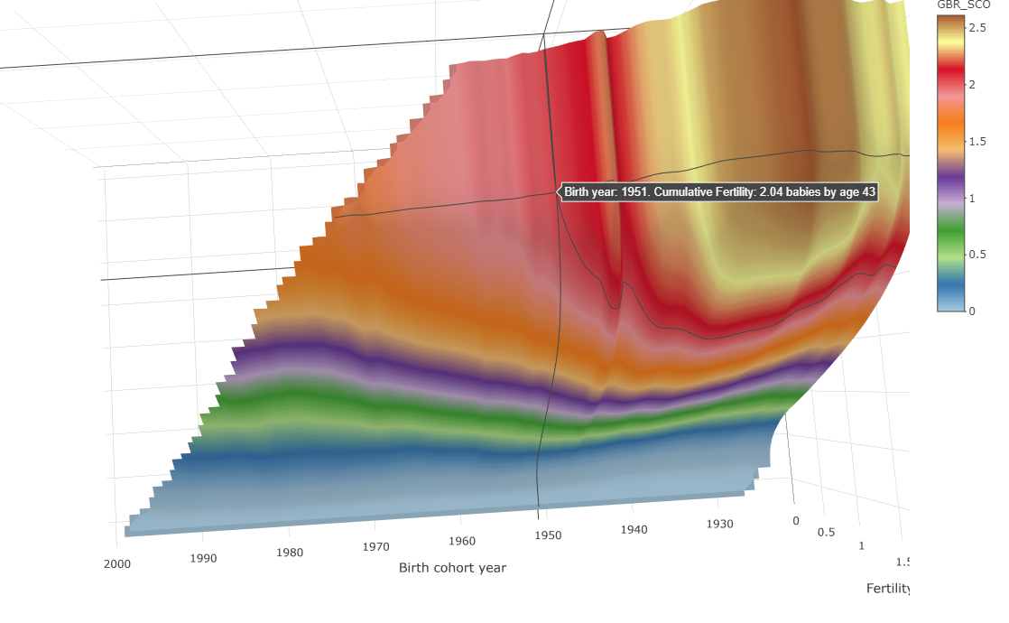

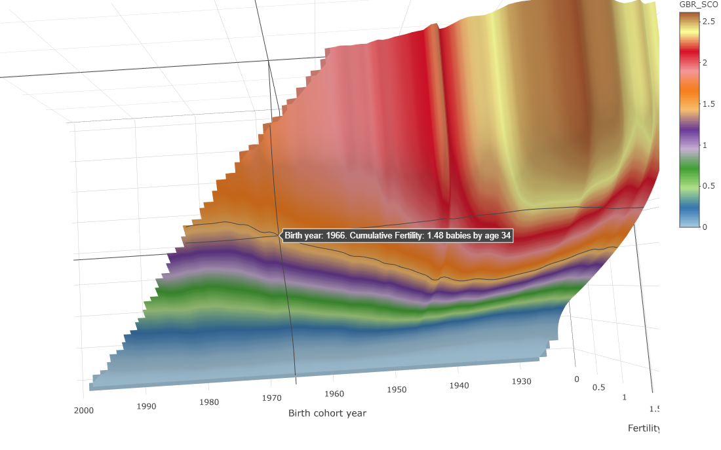

The linked plots tab augments the 3D surface with linked plots which show ‘sweeps’ through the data, at the position the user hovers over, along either the year, birth year, or age axes. Along with a range of additional features, we hope the app will be useful both for helping to support readers in developing an initial understanding of what the composite plots visualize, then later in applying the visualization technique in demographic data analysis. By linking the app with the article, we hope both that the method of visualization which the article introduces can be more easily understood, and also that the reader is then able to start using the visualization method very quickly after reading the article in order to address those demographic issues of most interest to them.